# Extend Windows server 2008 R2 license

Problem: - window evaluation period of 15 days expired then shows error “Window License is expired”

Cause on System: - Window shut down within an hour’s to start it.

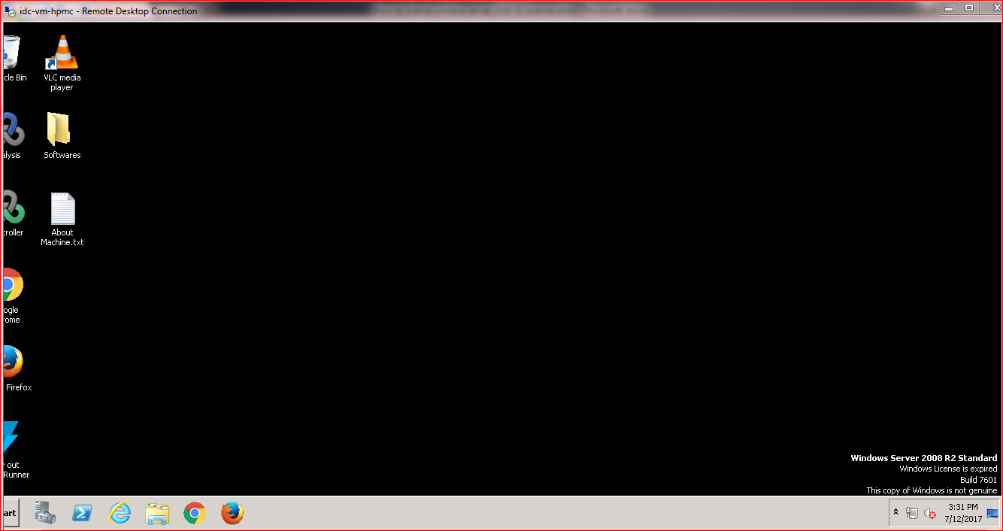

## Solution: - Extend the window license period.

Steps to extend the window license period to 180 days.

### Step 1: - Open the elevated command prompt.

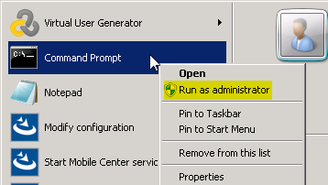

### Step2: - Change directory to c:\windows\system32

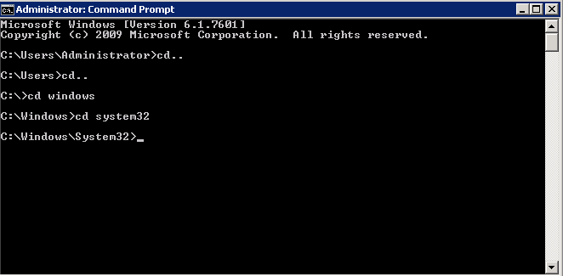

### Step 3: - Enter command slmgr.vbs /rearm

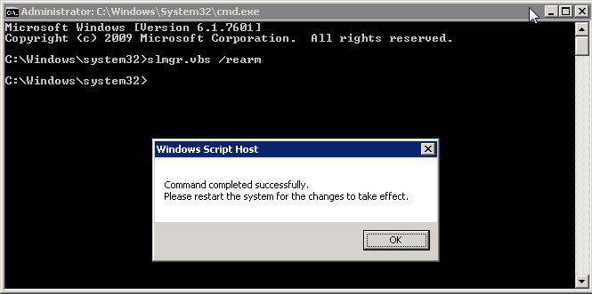

To apply this command restarts the system.

After restart you can see that message will be “**10 days to active.Active window now**”

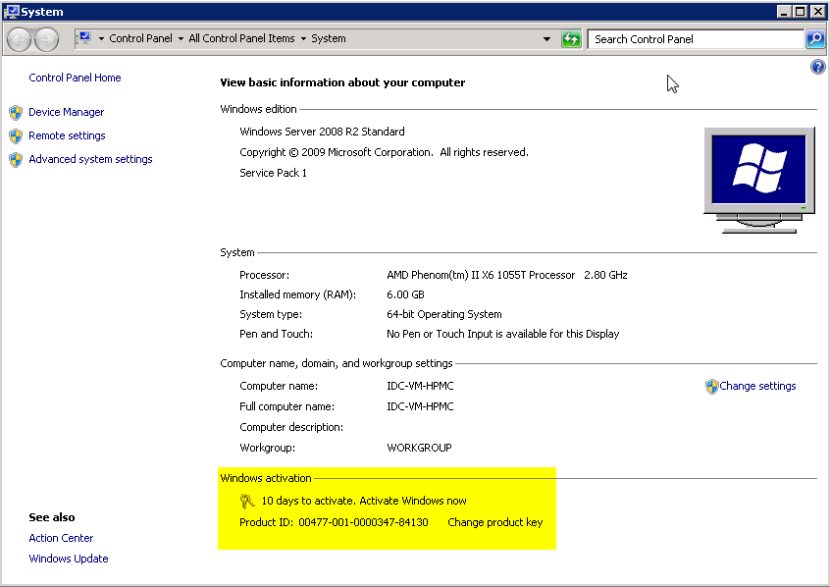

### Step 4: -Again open elevated command prompt with directory c:\windows\system32

### Step 5: - Run command slmgr.vbs -ato

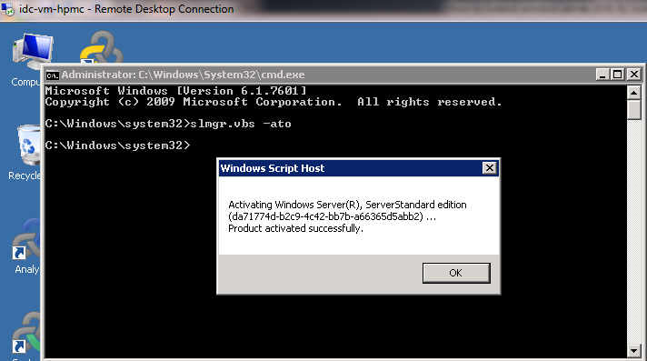

After this product activation message will be populated.

And you can see the will be extended for 180 days.

